Programming in C

**Drishya Neupane** **Ms.Rabina Chaudhary**

BE Software Programming in C

Roll no: 201648 Software Department

**Practical No: 1**

**Title:** TO LEARN THE BASICS OF C PROGRAMMING

**Objective:**

1. Understanding the basics of C programming
2. Understanding data types, variables, variable declaration, variable initialization, constants
3. Understanding the proper use and relation of Algorithm and Flowchart in Programming

**Theory:**

* Algorithm: The step by step procedure to perform a task is known algorithm. The sequence of steps when executed in proper or correct order helps us get desired result.
* Flowchart: Flowchart is the diagrammatical representation of an algorithm.

Flowcharts are more convenient to understand and interpret.

* Constant: Constant is an entity that doesn’t change its value throughout the program
* Variable: Variable is an entity that changes its value according to the program.
* Data Types: Data type specifies the type of data that a variable can store such as integer, float, character, double. This determines the type and size of data associated with variables.
* Variable Declaration and Initialization: Variable declaration and initialization is the process of declaring a variable to a certain address in the beginning of a program using different data type according to the type, size and precision needed. When a variable is declared, initialization should also be done.

Example:

#include<stdio.h>

int main() {

int a; 🡨 (Here a is a variable which is being declared as an integer)

char b;

printf("Size of a: %dbytes\n",sizeof(a));

printf(“Size of b: %dbyte\n”,sizeof(b));

return 0;

}

OUTPUT

Size of a: 4 bytes 🡨(Here we can see that diff data type occupies different

Size of b: 1 byte space)

**Practical:**

1. **Write a program to read the graphical characters and print their equivalent ASCII code**

Algorithm:

Step 1: Start

Step 2: Declare variable a

Step 3: Display "Input the ASCII value whose character is to be determined"

Step 4: Input the ASCII value

Step 5: Display the corresponding character

Step 6: Stop

Flowchart:

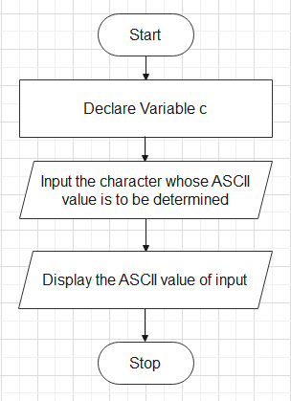

Program:

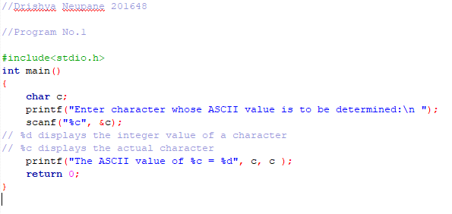

Output:

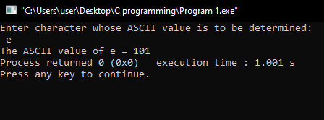

1. **Write a program to read ASCII value and print the equivalent character**.

Algorithm:

Step 1: Start

Step 2: Declare variable a

Step 3: Display "Input the ASCII value whose character is to be determined"

Step 4: Input the ASCII value

Step 5: Display the corresponding character

Step 6: Stop

Flowchart:

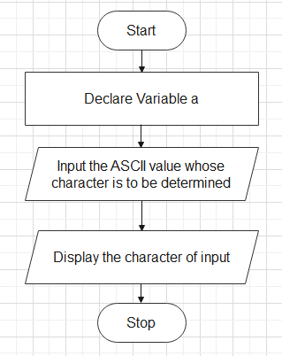

Program:

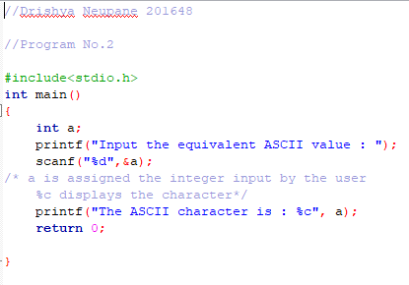

Output:

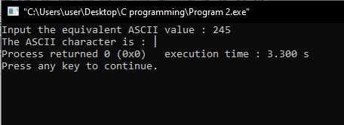

1. **Write a program to read the value of two variables, compute sum, difference and product**

Algorithm:

Step 1: Start

Step 2: Declare variable a, b

Step 3: Display "Input two numbers"

Step 4: Input two numbers

Step 5: Sum = a + b, Difference = a - b, Product = a * b

Step 6: Display Sum, Product, Difference

Step 7: Stop

Flowchart:

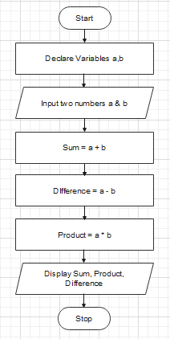

Program:

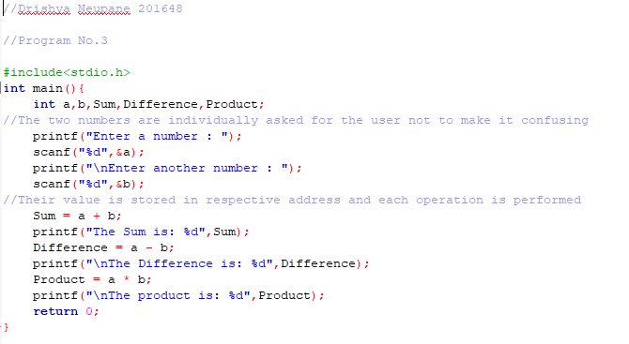

Output:

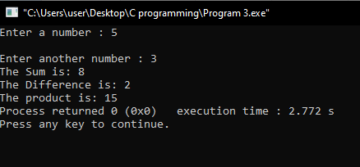

1. **Write a program to calculate cb3/d2**

Algorithm:

Step 1: Start

Step 2: Declare variable b,c,d

Step 3: Display "Input the value of b, c, d"

Step 4: Input the values of b, c, d

Step 5: Result = (c*(b^3))/(d^2)

Step 6: Display Result

Step 7: Stop

Flowchart:

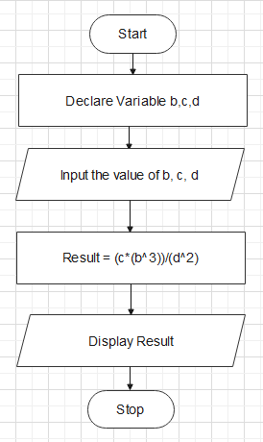

Program:

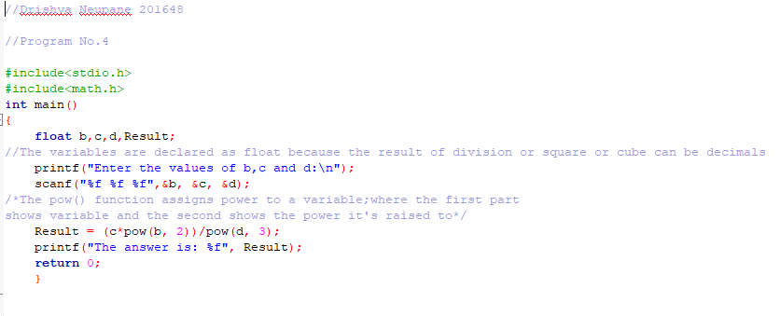

Output:

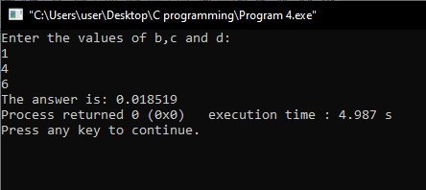

1. **Write a program to read radius of sphere and calculate volume and surface area**

Algorithm:

Step 1: Start

Step 2: Declare variable r

Step 3: Display "Input the radius of sphere 'r'"

Step 4: Input radius r

Step 5: Volume = 1.333*3.14*(r^3), Surface Area = 4*3.14*(r^2)

Step 6: Display Volume, Surface Area

Step 7: Stop

Flowchart:

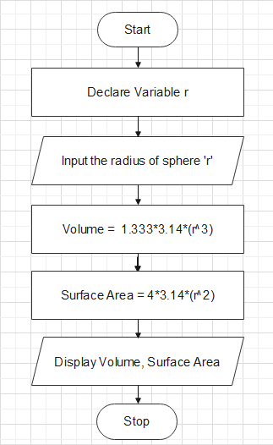

Program:

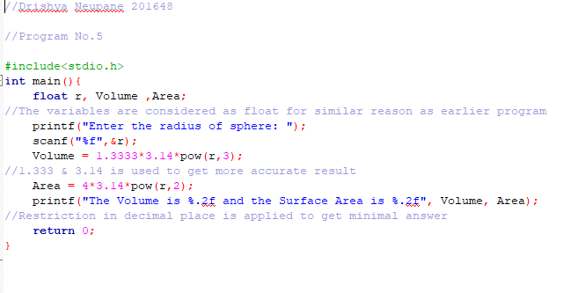

Output:

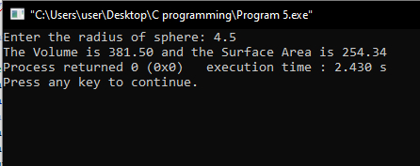

1. **Write a program to read the radius of circle and calculate the circumference and area**

Algorithm:

Step 1: Start

Step 2: Declare variable r

Step 3: Display "Input the radius of circle 'r'"

Step 4: Input radius r

Step 5: Circumference = 2*3.14*r,Surface Area = 3.14*(r^2)

Step 6: Display Circumference, Surface Area

Step 7: Stop

Flowchart:

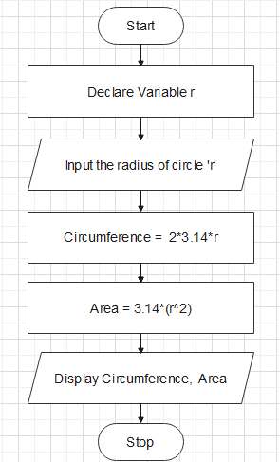

Program:

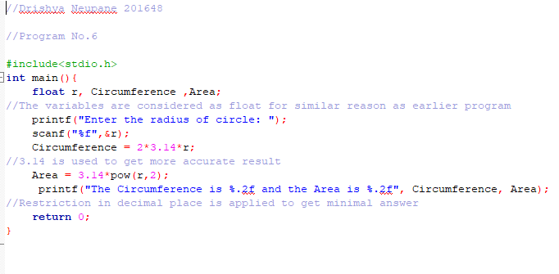

Output:

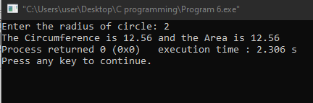

1. **Write a program to calculate the sum of following series**
2. **x2/2! + x4/4! + x6/6! + x8/8! - x10/10!**

Algorithm:

Step 1: Start

Step 2: Declare variable x

Step 3: Display "Input the value of x"

Step 4: Input the value of x

Step 5: Sum = 1 - 1-((x^2)/2!)+((x^4)/4!)+((x^6)/6!)+((x^8)/8!)-((x^10)/10!)

Step 6: Display Sum

Step 7: Stop

Flowchart:

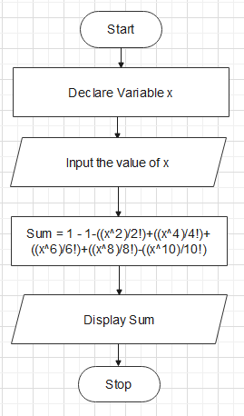

Program:

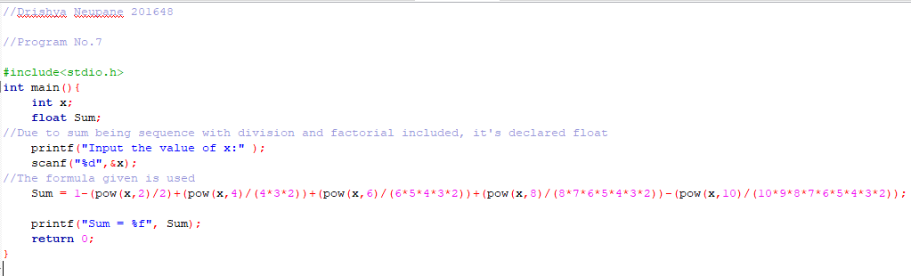

Output:

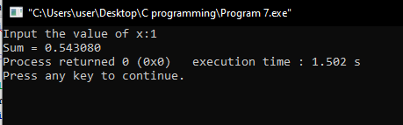

1. **Write a program to read the temperature in centigrade and convert it to Fahrenheit [hint F = 1.8C +32]**

Algorithm:

Step 1: Start

Step 2: Declare variable C

Step 3: Display "Input the temperature in Celsius"

Step 4: Input temperature in Celsius

Step 5: F = (1.8*C)=32

Step 6: Display F

Step 7: Stop

Flowchart:

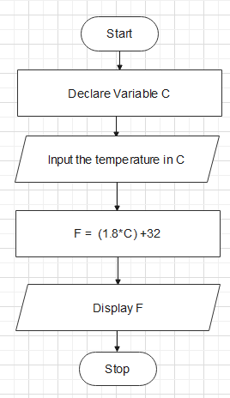

Program:

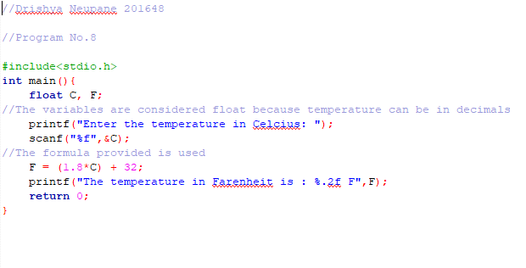

Output:

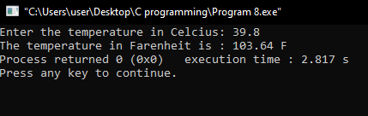

1. **Write a program to read the principle, time and rate and calculate the interest and total amount**

Algorithm:

Step 1: Start

Step 2: Declare variable P, T, R

Step 3: Display "Input the Principle, Rate and Time"

Step 4: Input Principle, Rate and Time

Step 5: I = (P*T*R)/100, A = P + I

Step 6: Display I and A

Step 7: Stop

Flowchart:

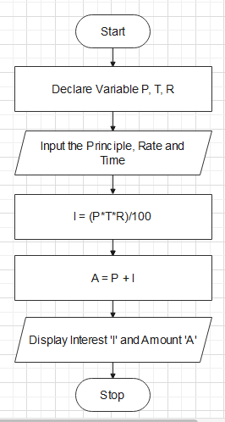

Program:

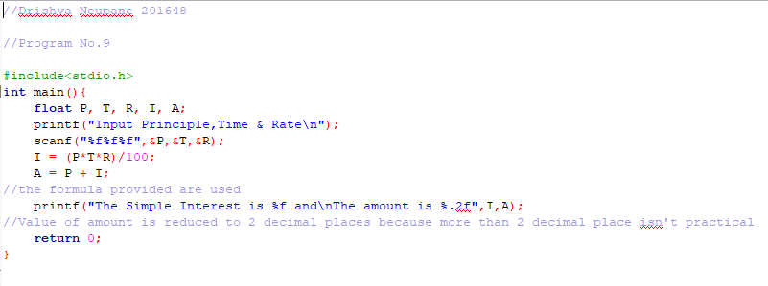

Output:

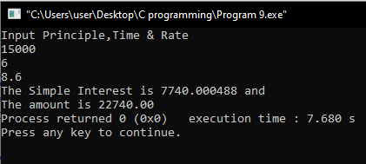

1. **Calculate the mass of air in an automobile tire, using the formula**

**PV = 0.37 m ( T + 460 )**

**Where P = Pressure, T = Temperature and V = Volume**

*(For this question we re-arrange the formula to find m)*

Algorithm:

Step 1: Start

Step 2: Declare variable P, V, T

Step 3: Display "Input the Pressure, Volume and Temperature of the automobile tyre"

Step 4: Input Pressure, Volume and Temperature

Step 5: M = (P*V)/((T + 460)*0.37)

Step 6: Display M

Step 7: Stop

Flowchart:

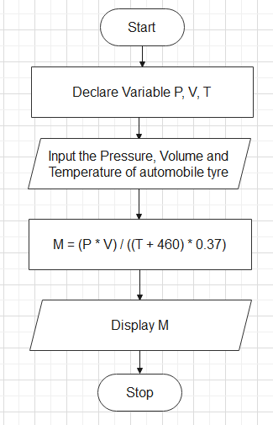

Program:

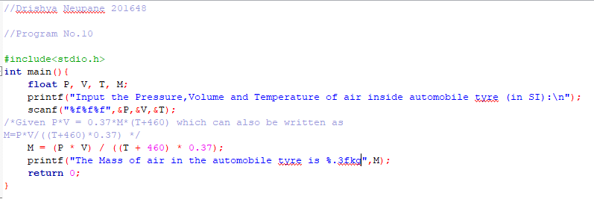

Output:

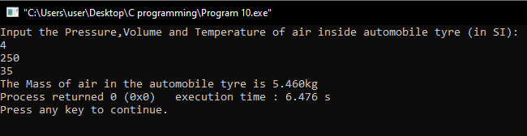

1. **Write a program to calculate real and equal roots of a quadratic equation.**

Algorithm:

Step 1: Start

Step 2: Declare variable a, b, c

Step 3: Display "Input the coefficient of x^2, x and constant of the quadratic equation"

Step 4: Input coefficient of x^2, x and constant (i.e. a, b, c)

Step 5: Check if (b^2)-(4*a*c)>0

Step 5.1: If Step 5 is true

Step 5.1.1: Check if (b^2)-(4*a*c) ==0

Step 5.1.1.1: If Step 5.1.1 is true

Step 5.1.1.1.1: The roots are equal, Alpha=Beta=-b/(2*a)

Step 5.1.1.1.2: Display Alpha, Beta

Step 5.1.1.2: If Step 5.1.1 is false

Step 5.1.1.2.1: Alpha = (-b - ((b^2) - 4*a*c)^0.5)) / (2*a)

Beta = (-b + ((b^2) - 4*a*c)^0.5)) / (2*a)

Step 5.1.1.2.2: Display Alpha, Beta

Step 5.2: If Step 5 is false

Step 5.2.1: Display the roots are imaginary

Step 6: Stop

Flowchart:

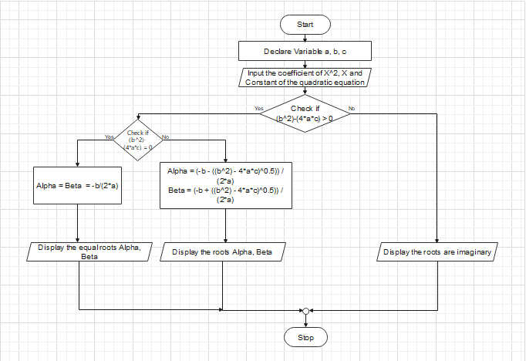

Program:

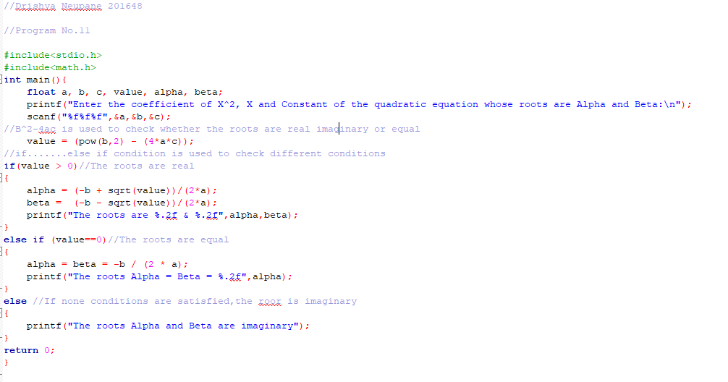

Output:

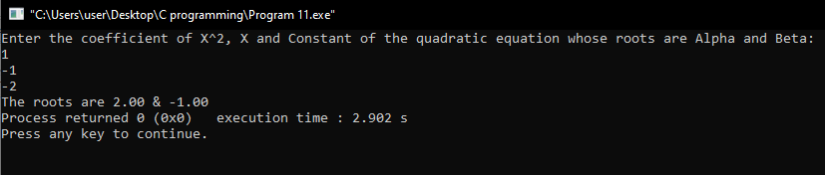

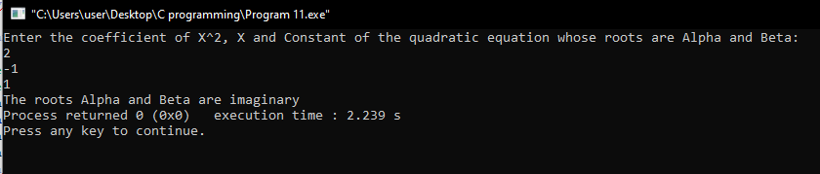

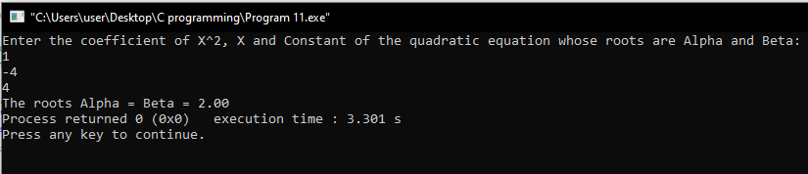

1. **Write a program to read the weight in gram and convert it to kilogram and gram.**

Algorithm:

Step 1: Start

Step 2: Declare variable g

Step 3: Display "Input the mass in gram"

Step 4: Input the mass in gram

Step 5: kg = g/1000, gi= g%1000

Step 6: Display kg and gi

Step 7: Stop

Flowchart:

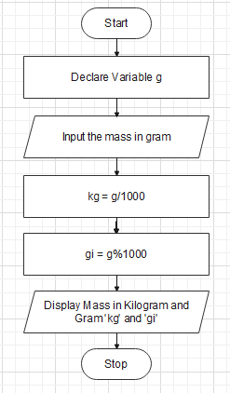

Program:

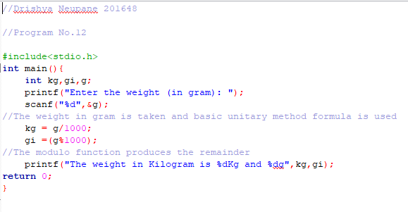

Output:

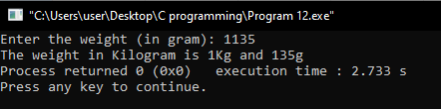

1. **Write a program to use sizeof operator to determine the size of different data types.**

Algorithm:

Step 1: Start

Step 2: Declare variable idata, fdata, dtdata, cdata

Step 3: Use Sizeof() function to determine size

Step 4: Display the size of int idata, float fdata, double dtdata and character cdata

Step 5: Stop

Flowchart:

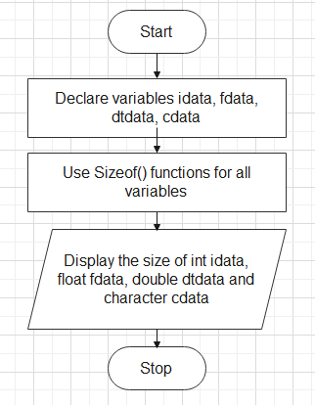

Program:

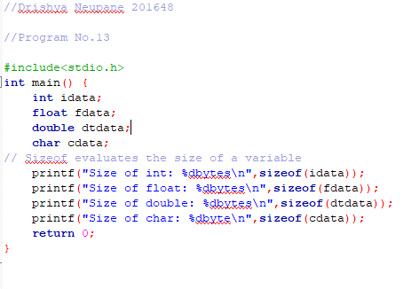

Output:

